**Assessing the attractiveness of opening an Italian restaurant in India**

**Abhiram R Devesh**

**August 10, 2020**

**I Introduction**

**1.1 Background**

The year is 2021, the year after the deadly pandemic that brought the world to a standstill. The pandemic had made every business across the world to rethink their strategy in terms of their expansion plans and market entry. It was the similar story at Pasta Tales Inc., a leading chain of Italian cuisine restaurants based out of the United Kingdom. In early 2020, the top management had decided to enter the Indian market and wanted to open at least 3 restaurants across the country. The company had decided all the locations and as they were about to roll-out the plan to enter the market, the pandemic hit the world. Because of the pandemic, the board of directors at Pasta Tales Inc. decided to revisit their Indian market entry strategy and had asked the COO to come up with an analysis of relevant data points to back their decision of entering the Indian market with 3 restaurants.

**1.2 Problem**

1. Identify the number of restaurants in each city followed by number of restaurants catering to Italian cuisine across India
2. Understand the distribution of restaurants across various localities based on the cuisine in the cities of focus
3. Identify the number of establishments that are catering to the Italian cuisine along with alcohol and plot the same
4. Understand the cost distribution of the restaurants catering to Italian cuisine in a particular city
5. Key features that have to be part of the restaurant

**1.3 Interest**

By undertaking this analysis, the COO is aiding the Board of Directors to arrive at a decision about their market entry into India and thereby finalizing their strategies/plans to roll out their entry.

**II Data acquisition and cleaning**

**2.1 Data sources**

Dataset relating to the restaurants/eateries in India was accessed from Kaggle. The dataset was scraped from Zomato, a leading restaurant/food delivery aggregator in based in India. The dataset was last updated in the year 2019.

**2.2 Data description**

The data collected mainly comprised the following data points:

* Name – Name of the establishment
* Establishment – Type of establishment (26 various types of establishments viz. Bakery, Casual dining, Bar, Pub, Quick Bites)
* City – Location of the restaurant
* Locality – Details of the area within the city
* Latitude – Co-ordinates
* Longitude – Co-ordinates
* Cuisines – Type of cuisine catered to by the establishment
* Average Cost For Two
* Highlights – Key tags for the establishment (E.g. Takeaway, Valet available, Non-Smoking, Serves Alcohol etc.)
* Aggregate Rating – Rating for the establishment; Rated out of 5 (1 being “Poor”, 5 being “Excellent”)
* Rating Text – Text attributed based on the rating (1 being “Poor”, 5 being “Excellent”)
* Votes – Total number of votes for that establishment given by the users of Zomato

**2.3 Data cleanup**

* Converted the data types for select variables such as Latitudes, Longitudes, Average Cost for Two and Aggregate Rating

|  |  |  |  |
| --- | --- | --- | --- |
| Variable | Raw Datatype | Converted Datatype | Reason for conversion |
| Latitude | String | Float with 6 decimal places | For precise plotting on map |
| Longitude | String | Float with 6 decimal places | For precise plotting on map |
| Average Cost For Two | String | Integer | For correlation analysis |
| Aggregate Rating | String | Float with 1 decimal place | For correlation analysis |

* There were duplicate entries of many restaurants (Having the same location coordinates). These were removed to avoid bias in any of the analysis
* Data under the columns “Rating Text” and “Votes” were not used for the current analysis
* Data with empty fields were dropped from the data frame

**III Data Analysis**

The procedure and solutions for each of the problems facing the COO are addressed in this section

**3.1 Current restaurant scenario in India**

The entire restaurant scenario was plotted on to the map of India to understand the current scenario prevalent and to get a sense of the major concentrations of restaurants across India. This analysis was fine tuned to plot the restaurants across India that catered to only “Italian Cuisine”. This analysis answers the first problem statement under section 1.2.

Variables that were analysed as part of this analysis include:

* City
* Latitude
* Longitude
* Cuisines

Results of the analysis are presented below:

**Figure 3.01: Distribution of restaurants across India**

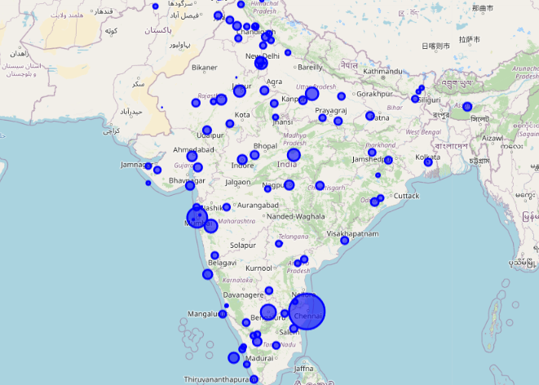

**Figure 3.02: Distribution of restaurants catering to Italian cuisine**

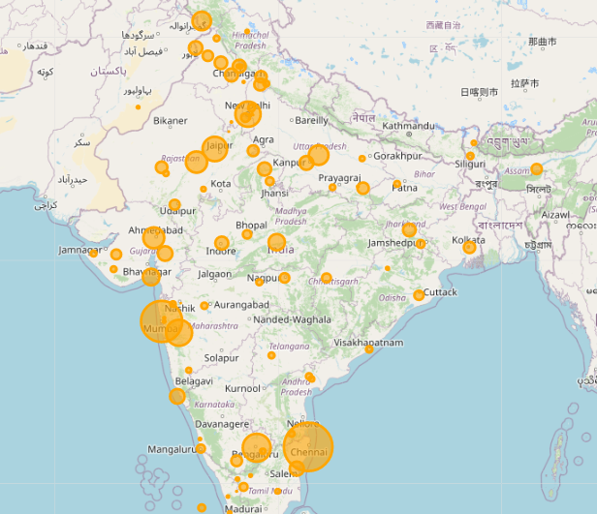

From these two analyses, the top 5 cities having largest concentration of restaurants catering to “Italian cuisines” were extracted and the same are listed below:

**Table 3.1: Top 5 Cities with restaurants catering to “Italian cuisine”**

|  |  |
| --- | --- |
| City | No. of restaurants catering to  “Italian cuisine” (Nos.) |
| Chennai | 1871 |
| Mumbai | 1588 |
| Bangalore | 1074 |
| Pune | 1004 |
| New Delhi | 972 |

**3.2 Detailed analysis for each city**

The objective of this analysis is to understand the distribution of restaurants across various localities based on Italian cuisine in the cities of focus. This analysis answers the second and third problem statements under section 1.2.

Variables that were analyzed as part of this analysis include:

* City
* Latitude
* Longitude
* Cuisines
* Highlights
* Average Cost For Two

Results of the analysis are presented below:

**Figure 3.03: Chennai – Distribution of Italian restaurants with ratings**

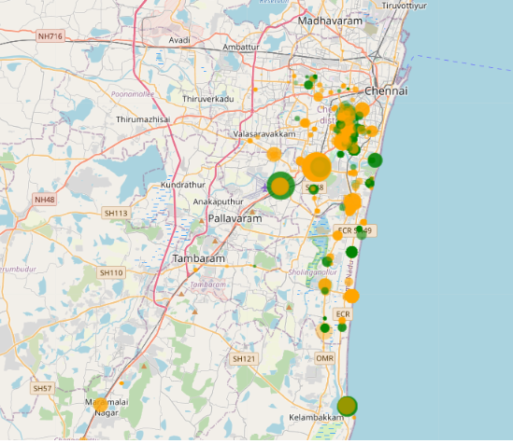

The average rating for the city of Chennai was 4.15. Restaurants with ratings above the city average has been plotted as Green Bubbles with the size of the bubble made proportionate to the restaurant’s Average Cost For Two. Orange Bubbles are restaurants with ratings below the city average.

**Figure 3.04: Mumbai – Distribution of Italian restaurants with ratings**

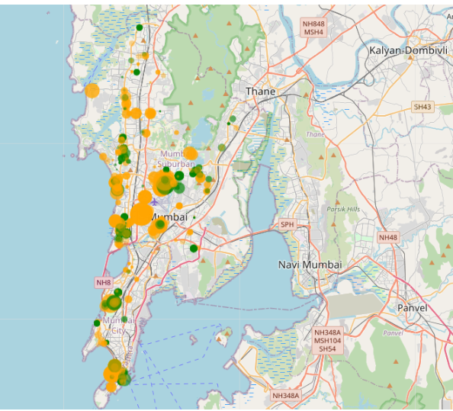

The average rating for the city of Mumbai was 4.20. Restaurants with ratings above the city average has been plotted as Green Bubbles with the size of the bubble made proportionate to the restaurant’s Average Cost For Two. Orange Bubbles are restaurants with ratings below the city average.

**Figure 3.05: Bangalore – Distribution of Italian restaurants with ratings**

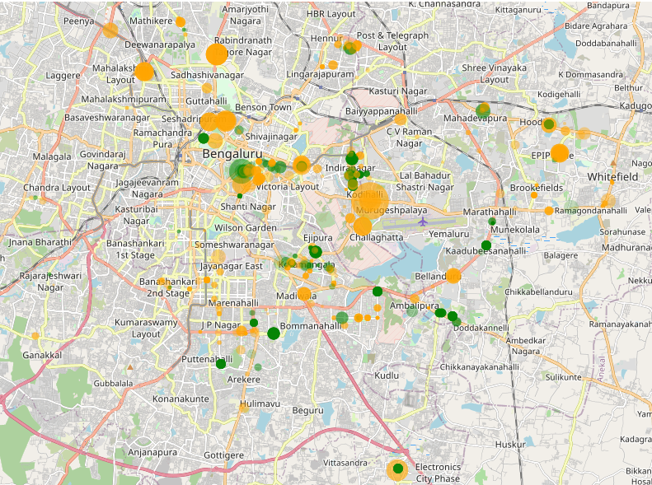

The average rating for the city of Bangalore was 4.30. Restaurants with ratings above the city average has been plotted as Green Bubbles with the size of the bubble made proportionate to the restaurant’s Average Cost For Two. Orange Bubbles are restaurants with ratings below the city average.

**Figure 3.06: Chennai – Distribution of Italian restaurants serving alcohol**

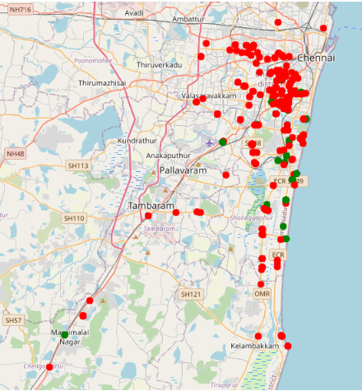

The analysis showed that only 455 restaurants serve alcohol while the remaining 1416 do not serve alcohol in Chennai. The Red dots indicate the Italian restaurants that do not serve alcohol and Green dots indicate the restaurants that serve alcohol in Chennai.

**Figure 3.07: Mumbai – Distribution of Italian restaurants serving alcohol**

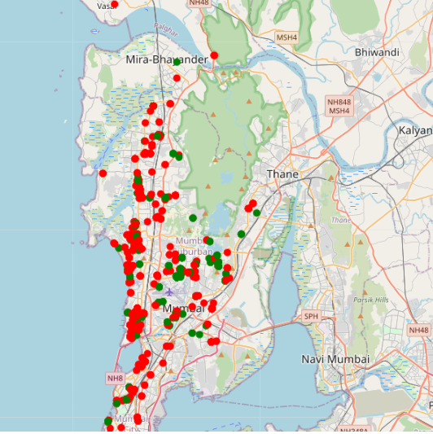

The analysis showed that only 588 restaurants serve alcohol while the remaining 1000 do not serve alcohol in Mumbai. The Red dots indicate the Italian restaurants that do not serve alcohol and Green dots indicate the restaurants that serve alcohol in Mumbai.

**Figure 3.08: Bangalore – Distribution of Italian restaurants serving alcohol**

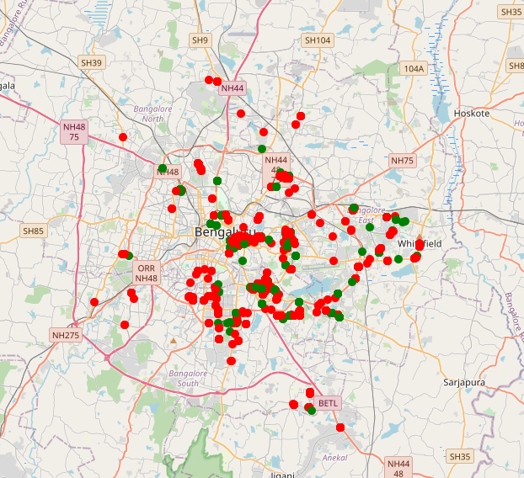

The analysis showed that only 317 restaurants serve alcohol while the remaining 757 do not serve alcohol in Mumbai. The Red dots indicate the Italian restaurants that do not serve alcohol and Green dots indicate the restaurants that serve alcohol in Mumbai.

**3.3 Analysis of Key “Highlights” of Italian restaurants**

The objective of this analysis is to understand the key highlights/features that the restaurant should have as part of its market entry strategy in the cities of focus. This analysis answers the fifth problem statement under section 1.2.

Variables that were analyzed as part of this analysis include:

* City
* Highlights
* Average Cost For Two
* Aggregate Rating

Results of the analysis for city of Chennai are presented below:

**Figure 3.09: Correlation matrix for the city of Chennai – Variant 1**

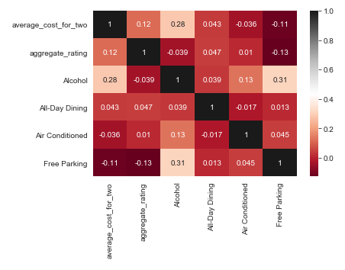

In Variant 1, we observe that there is a positive correlation between “Alcohol” and “Average Cost For Two”. There is also a minimal positive correlation between “Free Parking” and “Alcohol” – an unanticipated result of the analysis. We can infer that restaurants serving alcohol, and which are having free parking is a differentiator amongst other restaurants.

**Figure 3.10: Correlation matrix for the city of Chennai – Variant 2**

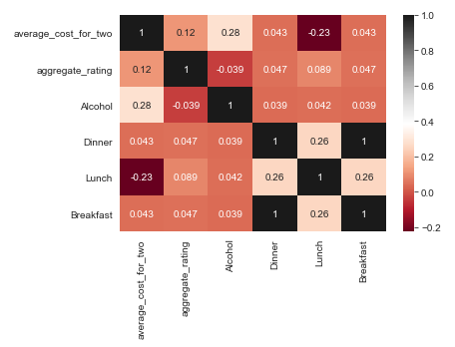

In Variant 2, we observe that there is a high positive correlation between “Breakfast” and “Dinner”. So, we can infer that All Day Dining mode of operations are preferred.

Results of the analysis for city of Mumbai are presented below:

**Figure 3.11: Correlation matrix for the city of Mumbai – Variant 1**

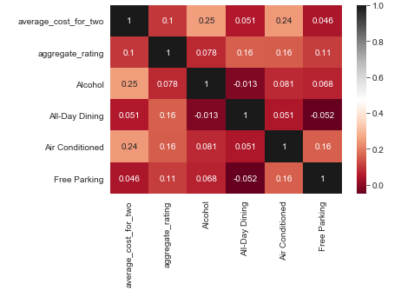

In Variant 1, same as correlation matrix of Chennai we also observe high positive correlation between “Alcohol” and “Average Cost For Two”. The correlation between “Free Parking” and “Alcohol” is very low in this city.

**Figure 3.12: Correlation matrix for the city of Mumbai – Variant 2**

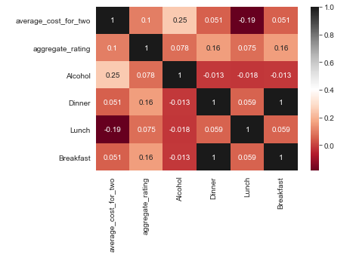

In Variant 2, we observe that there is a high positive correlation between “Breakfast” and “Dinner”. So, we can infer that instead of All-Day Dining mode of operations the restaurants can serve only Breakfast and Dinner as there is poor correlation between lunch and other meals

.

Results of the analysis for city of Bangalore are presented below:

**Figure 3.13: Correlation matrix for the city of Bangalore – Variant 1**

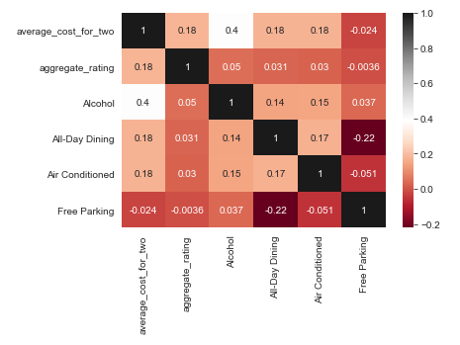

In Variant 1, same as correlation matrix of Chennai or Mumbai we also observe high positive correlation between “Alcohol” and “Average Cost For Two”. The correlation between “Free Parking” and “Alcohol” is also very low in this city.

**Figure 3.14: Correlation matrix for the city of Bangalore – Variant 2**

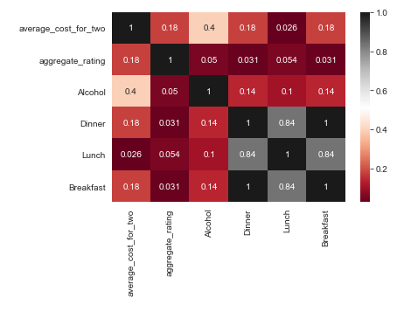

In Variant 2, we observe that there is a high positive correlation among all three meals. So, we can infer that instead of All Day Dining mode of operations the restaurants.

**IV Conclusion**

From this analysis, we can infer that Italian restaurants for the

1. City of Chennai with All Day Dining options, Free parking and which serves alcohol have good potential in Chennai.
2. City of Mumbai with only Breakfast and Dinner, and which serves alcohol have good potential.
3. City of Bangalore with All Day Dining options and which serves alcohol have good potential,